**Case Study #4 - Data Bank**

Danny Ma · June 1, 2021

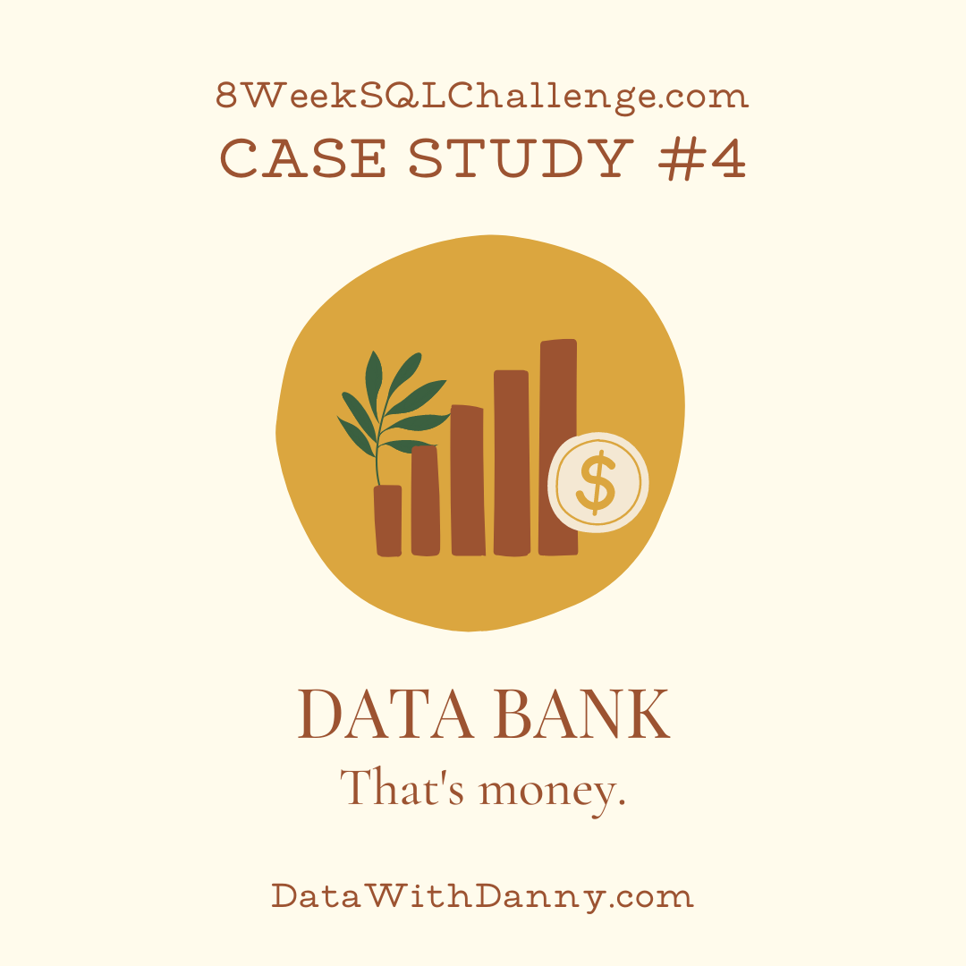

**Introduction**

There is a new innovation in the financial industry called Neo-Banks: new aged digital only banks without physical branches.

Danny thought that there should be some sort of intersection between these new age banks, cryptocurrency and the data world…so he decides to launch a new initiative - Data Bank!

Data Bank runs just like any other digital bank - but it isn’t only for banking activities, they also have the world’s most secure distributed data storage platform!

Customers are allocated cloud data storage limits which are directly linked to how much money they have in their accounts. There are a few interesting caveats that go with this business model, and this is where the Data Bank team need your help!

The management team at Data Bank want to increase their total customer base - but also need some help tracking just how much data storage their customers will need.

This case study is all about calculating metrics, growth and helping the business analyse their data in a smart way to better forecast and plan for their future developments!

**Available Data**

The Data Bank team have prepared a data model for this case study as well as a few example rows from the complete dataset below to get you familiar with their tables.

**Entity Relationship Diagram**

